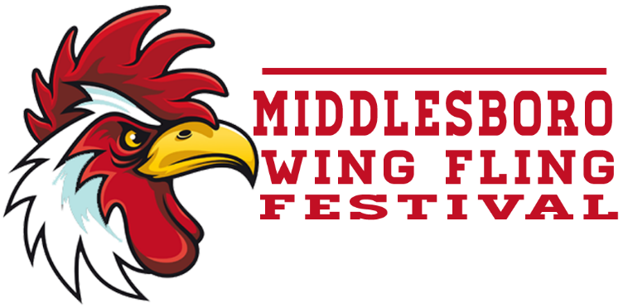
6th ANNUAL WING FLING
The summer air of Downtown Middlesboro, KY will be filled with a buzz and aroma like it has never sensed before. Our 6th annual Wing Fling will be held September 17th, 2022 on the city parking lot. Enter that favorite recipe and let the judges prove, once and for all, that your wings are second to NONE!!
Here’s what you need to know…
- BOOTH INFORMATION
A space will be provided which is perfect for a pop-up canopy tent. You will need to provide the general materials for your booth such as tables, utensils, napkins, etc. You will also need to provide all the materials and equipment necessary for cooking your wings. 110v is available upon request. You may decorate and advertise your booth however you wish.

- WHERE IS IT?
The Wing Fling competition will be located in the city parking lot in downtown Middlesboro.

- WHAT IS THE COST?
The entry fee is $200 per team. 110V electrical hook-up is available upon request and included in your entry fee.

- HOW DO I APPLY?
Once the rules and regulations sheet have been read completely, fill out an application, sign it, and pay your fee. This means you accept the rules and regulations and are ready to compete. Then submit application and fee to:
Middlesboro Main Street
PO Box 1156
Middlesboro, KY 40965
(Checks made payable to: Middlesboro Main Street)

- WHAT DOES MY FEE BUY?
Upon paying your fee, you will receive entry to the wing competition, a generous booth space, and approx. 80-100 lbs. of chicken wings.

- WHAT CAN I WIN?
On top of getting a big head from bragging about your wings, 1st Place receives $2,500. 2nd Place receives $1,500. 3rd Place receives $1,000. A trophy will be awarded to the Fan Favorite Champion along with a free entry into the following years Wing Fling Festival which is the competitor that receives the most votes from the “Fan Favorite” ticket.

- HOW IS IT JUDGED?
Each entry will be judged through a blind judging process that guarantees fairness to all the competitors. The ruling of these judges is final.

THE JUDGING PROCESS…
Entries should be submitted in a numbered container, provided by the organizer.
The container should not be marked in any way so as to make container unique or identifiable. Aluminum foil, toothpicks, skewers, foreign material, and/or stuffing are prohibited in the container. Marked entries or containers with the above listed material will receive a one (1) in all criteria from all Judges and disqualified.
Each contestant must submit at least 12 wings. If there is not enough for each judge to sample, the shorted judge(s) will score a one (1) on all criteria, and the judges having samples will change the Appearance score to one (1) as a penalty.
Judging Procedures
The container may be re-numbered by the Rep before being presented to the judges.
- Judges may not enter team areas until the conclusion of judging.
- Judging will be done by at least 6 persons at each judging table. Rep will determine the optimum number of tables of judges needed to properly judge the contest. Judges, Reps and necessary support staff only are allowed in the judging area during the judging process. No other activities are permitted in the judging area during the judging process.
- Each judge will first score all the samples for appearance. The turn-in containers will then be passed around the table and each judge will place a sample from each of the containers in the box on the judging plate. The judge will then score each entry for taste and execution before moving to the next entry.
- The scoring system is from 2 to 9, all whole numbers between two and nine may be used to score an entry. 9 excellent, 8 very good, 7 above average, 6 average, 5 below average, 4 poor, 3 bad, 2 inedible.
- A score of one (1) is a penalty or disqualification and requires approval by a rep. Grounds for penalty/disqualification: All judges will give a one (1) in all criteria for sculptured meat, a marked turn-in container, or foreign object in the container. All judges not receiving a sample will give a one (1) in all criteria.
- The weighing factors for the point system are: Execution – 1.1428, Appearance - .56, Taste – 2.2972.
- The low score will be thrown out. Results will be tallied. If there is a tie the scores will be compared for the highest cumulative scores in taste, then execution, then appearance. If still tied, then the low score, which was thrown out, will be compared and the higher of the low scores will break the tie. If still tied, then a coin toss will be used.

TEAM REQUIREMENTS…
- Your team is required to provide all necessary items for the cooking of your wings as well as all general materials for your booth.
- Bring a box/container to collect the Fan Favorite tickets.
- SAFETY IS FIRST AND FOREMOST TO US! In consideration of Middlesboro Main Street allowing the undersigned to take part in the Wing Fling, the undersigned agrees to save, defend and hold harmless the City of Middlesboro, Middlesboro Main Street, it’s sponsors, agents, representatives, successors and employees from any and all claims for damages for injury (including death) and property damage of any kind including but not limited to attorney fees and others costs of responding to or defending a claim or litigation which may occur from the organization/individual(s) involvement with the event.
ON THE DAY OF THE CONTEST…
7:00 am – 9:00 am Unload and setup

9:00 am Cook meeting with Contest Officials &
distribution of chicken wings

11:00 am Turn-In for judging

11.30 am Open to public

4:00 pm Winners announced

5:00 pm Contest ends
Thank you for your cooperation and good luck!
For questions or comments please call or email us at:
Joanie @ 712-259-1382
downtownmiddlesboro@gmail.com
www.facebook.com/wingflingmboro

